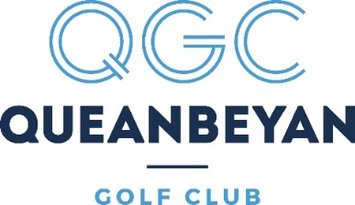

MEMBERSHIP SUBSCRIPTIONS 2022 – 2023

The Board of Directors and management are pleased to advise of the following membership categories and subscriptions on offer for the 2022 – 2023 membership year commencing 1 August 2022. Renewals will be accepted from 15 June 2022 through MiClub.
There are a number of changes to membership categories this year. Some lesser populated categories have been retired and a new lifestyle category has been introduced for those who do not wish to commit to full playing golf membership. A joining fee has also been introduced for new and lapsed members.
Subscription increases have been kept to a minimum but are necessitated by the significant increases in course expenditure. Subscriptions are set on the basis of maintaining the golf course to a standard that all members can be proud of.
Please review the options on offer and if you have any questions please do not hesitate to contact the office on (02) 62971669 for further details.

CATEGORY | FEE | INCLUSIONS
GOLFING CATEGORIES
JOINING FEE | $300 | Applies to all new adult membership applications
FULL PLAYING - CLASSIC | $1650 | Seven (7) day playing access. Includes $100 club account
ELDER | $1300 | Over 65 years of age with 25 years continuous years of FULL PLAYING (7 DAY) membership. Includes $100 club account
CLUB ACTIVE  (exclusions apply) | $1000 | Please see attached
YOUNG ADULT (18 – 24 YO) | $650
JUNIOR (8 – 17 YO) | $100
PRIVATE CART USAGE FEE | $200 | Use of private motorised golf cart
LOCKER FEE | $150 | Oversized storage locker
NON-GOLFING CATEGORY
- CLUBHOUSE | $10.00 | Use of clubhouse facilities only – expires 3 years from purchase

Direct Debit is available for monthly instalments on Full playing, Young adult and Elder membership categories Only. A $120 annual administration fee applies.

