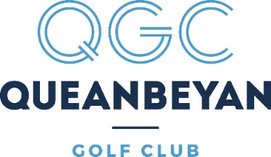

CLUB ACTIVE – Lifestyle membership

The QGC is pleased to announce an exciting new category of Club Membership - Club Active - which will commence on 1 August 2022.
Club Active is a ‘points based’ lifestyle membership catering for members for whom a full membership does not meet their needs. Initial Club Active membership is $1000 for 1000 pts. Points are deducted based on the day of play and the number of holes played ie. more points are required on a Saturday (high demand) than a Monday (low demand). Points will be managed through the MiClub Management System and all bookings are to be made through MiClub. Competition fees are not included.

Club Active membership will need to be considered carefully as there are a number of restrictions. Club Active members will have no voting rights, will be ineligible for Club Championships or pennant teams.

Club Active membership fees will be required to be paid in full with points reverting to zero at the end of the financial year. Additional top-up points can be purchased in blocks of 250 points for $300.

18 Holes 9 Holes (minimum)
Monday 20 10
Tuesday 25 13
Wednesday 30 15
Thursday 20 10
Friday 25 13
Saturday 45 23
Sunday 30 15

