*Important notice to all members - New Online Booking System

Our new look and feature filled golf operation system will be available for practice from February 23 2022. Club management and staff will receive training on the new system on February 17, 18 and March 15. This new ‘MiClub’ Online golf system is in use by over 500 clubs in Australia including, Cottesloe Golf Club, Port Macquarie GC, Sanctuary Cove GC, Royal Sydney GC, Riverside Oaks GC, Barwon Heads GC and The National GC (Cape Schanck). The new online golf system can be accessed through the Queanbeyan Golf Club website or by selecting the below link:

https://queanbeyangolf.miclub.com.au/security/login.msp

Logging on
Your username is your member number and your new temporary password is now your birth day and month (e.g. "0705" for 7 May). Please contact the club if you have any problems with the initial login. Once logged on you will be prompted to change your password. Your new password must be a minimum of 7 characters including 1 lowercase letter, 1 uppercase letter, 1 number and 1 special character and cannot contain your username/member number. This password format is essential for Queanbeyan Golf Club to provide a secure system for our users.
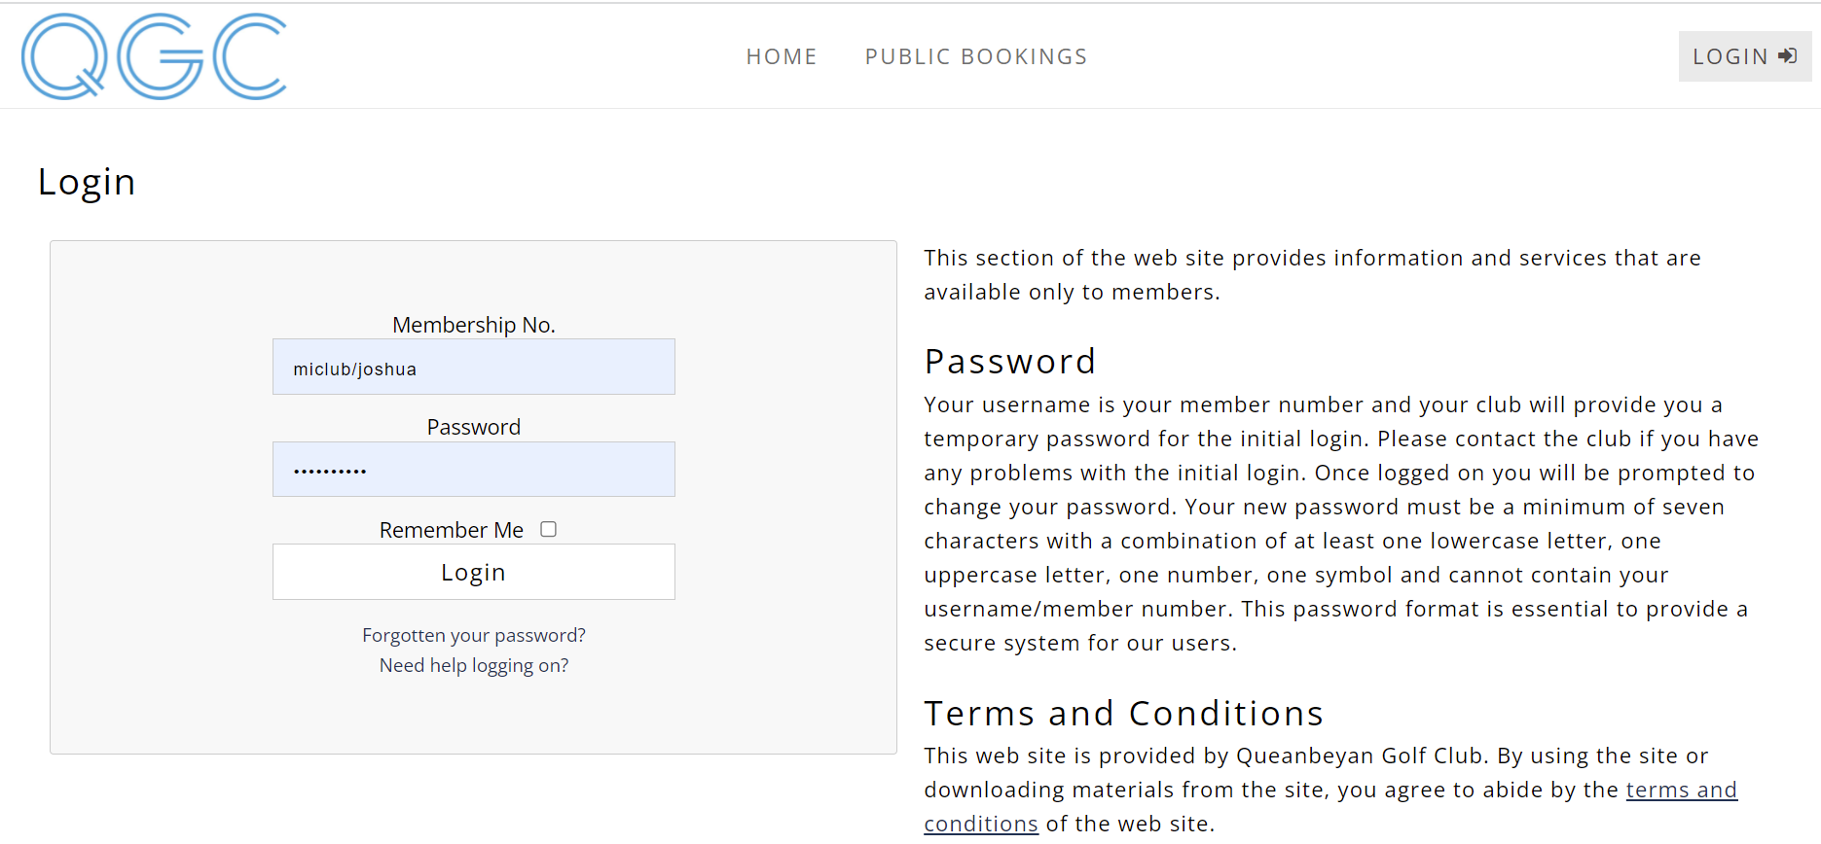
Trouble logging in?
Please contact the office ASAP.

Update your details
When you 1st login please update your member details. In particular phone numbers and email address, this will greatly assist the club in keeping all members information up to date.
All members’ details are private unless you choose otherwise.

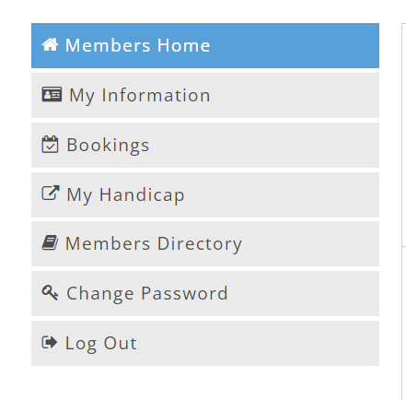

Members page
Once logged onto the site you will be taken to your own personal welcome page. The home page will have ‘posts’ which you can view to see how some features work e.g. card scanning, playing partners, lottery feature for timesheets opening online.
On this page you will see your contact details, a link to your golf bookings, golf competition results, a playing partner’s setup instructional post, card scanning post and a general Club notice board. From this screen you will also be able to navigate around the complete site including many pages which are only available to members of the club.
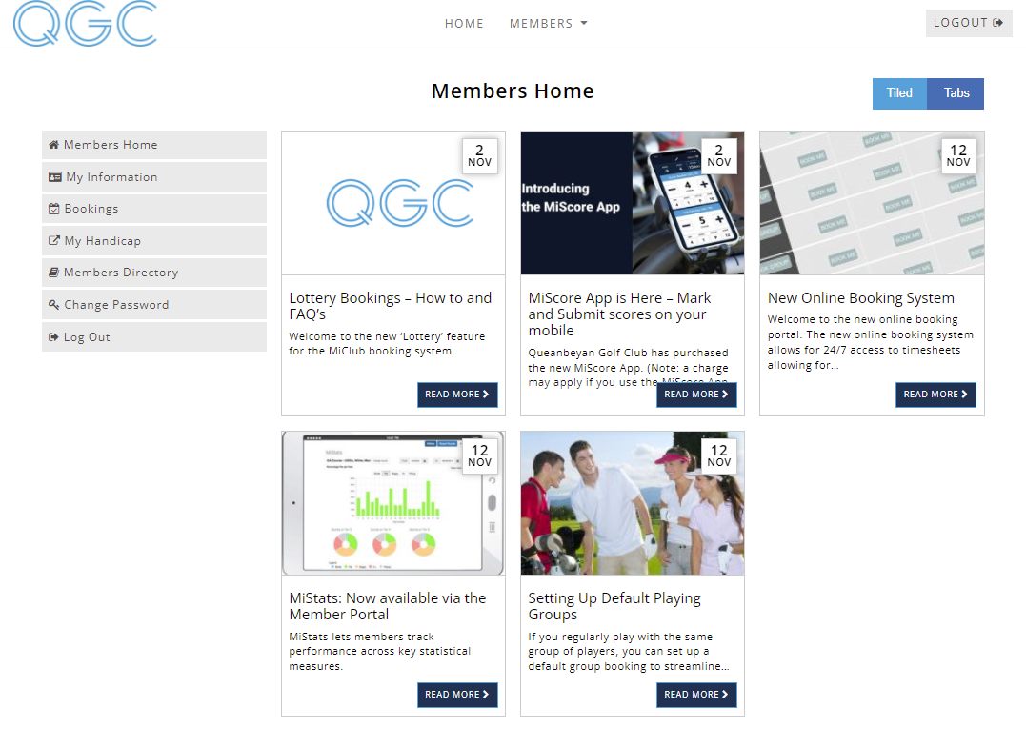Members will also have access to a ‘My Information’ page which gives members access to live competition leaderboards, past competition results as well as ‘MiStats’ which tracks the performance of each member in competition play. This feature will display the members best and worst holes as well as birdie, par and bogey percentages.

New Online Timesheet System
Once logged in, navigate to the Timesheets area by clicking on ‘Bookings’ which will appear
In the accordion on the left or via the ‘Members’ drop down option at the top.

Practice timesheets will be available on the new member’s online booking facility on February 23. These practice timesheets exist for practice bookings only.

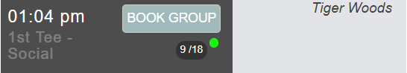

Please be aware that the 1st Online Timesheet with the new system will be for March 16. This timesheet will open for bookings on March 2 with normal bookings applying.

Timesheets exist for every day, please be sure to book, to avoid disappointment. Any course closures and or syllabus changes will be updated on the website. Similar to making a booking, members can also delete their booking by selecting the red cross next to their name on the timesheet. Timesheets for online bookings close at normal times, from then on, any cancellations must be made through the Pro Shop.

Timesheet changeover period
Timesheets up until March 15 will be booked via the old system / method.
Timesheets from March 16 (inclusive) will be booked via the new MiClub system.

Reminder emails
Once live the booking system will automatically send email reminders 48 hours prior to any golf booking. If you cannot play at this booked time, please remove yourself ASAP to allow an opportunity for another member to play.

Additional Links (e.g. Card Scanning Tutorial, APP Scoring Tutorial)

Scoring APP Download - https://miscore.com.au/download/
Scoring APP Introduction - https://www.youtube.com/watch?v=k0V3ZzLlako
Scoring APP (Tips / Tricks) - https://www.youtube.com/playlist?list=PLDbKx54MDUWBjxRJTOeobPGnRrlJDa7Kp

Additional Notes

- You may have the old booking system book marked / saved on your browser. Ensure you delete it and book mark / save the new system.
- When you login for the first time, please update your password and save it or make note of it. (It is required to be a minimum or seven characters with a combination of at least one lower case letter, one upper case letter, one number, one symbol, and cannot contain your username / member number.)

